Connected Component Labeling
Code:
import cv2
import numpy as np
import matplotlib.pyplot as plt
image = cv2.imread('era.jpg', cv2.IMREAD_GRAYSCALE)
binary_image = cv2.threshold(image, 127, 255, cv2.THRESH_BINARY)
num_labels, labels = cv2.connectedComponents(binary_image)
colored_labels = cv2.applyColorMap(np.uint8(labels * 255 / num_labels), cv2.COLORMAP_JET)
plt.subplot(121), plt.imshow(binary_image, cmap='gray'), plt.title('Binary Image')
plt.subplot(122), plt.imshow(colored_labels), plt.title('Connected Components')
plt.show()
print(f"Total connected components found: {num_labels - 1}")
Code Explanation:
The code performs Connected Component Labeling (CCL) on a binary image to identify and label the connected components within the image. Below is a detailed breakdown:
- Image Loading:
image = cv2.imread('era.jpg', cv2.IMREAD_GRAYSCALE)
This line loads an image named "era.jpg" (or another format like PNG, JPEG, etc.) in grayscale. Grayscale is used because connected component labeling typically operates on binary (black and white) images, and working in grayscale simplifies this process.
- Thresholding:
_, binary_image = cv2.threshold(image, 127, 255, cv2.THRESH_BINARY)
This step converts the grayscale image to a binary image. All pixel values greater than 127 will be set to 255 (white), and all pixel values less than or equal to 127 will be set to 0 (black). This binary image is what CCL will process, as the foreground (objects) should be white, and the background should be black.
- Connected Components Labeling:
num_labels, labels = cv2.connectedComponents(binary_image)
This function returns two values:
  - num_labels: The number of connected components found, including the background.
  - labels: An image where each pixel is labeled with a unique integer corresponding to the connected component it belongs to.
- Visualization of Labeled Components:
colored_labels = cv2.applyColorMap(np.uint8(labels * 255 / num_labels), cv2.COLORMAP_JET)
This line colors the labeled components for better visualization:
  - The labels array is normalized and mapped to color using the applyColorMap function. This makes the components visually distinct.
  - The cv2.COLORMAP_JET applies a color map where different components are assigned different colors.
- Displaying the Results:
plt.subplot(121), plt.imshow(binary_image, cmap='gray'), plt.title('Binary Image')
plt.subplot(122), plt.imshow(colored_labels), plt.title('Connected Components')
plt.show()
This block uses matplotlib to display the binary image and the colored version of the labeled components side by side. The first subplot shows the binary image, and the second subplot shows the labeled components in color.
- Print the Number of Connected Components:
print(f"Total connected components found: {num_labels - 1}")
This prints the number of connected components found. The -1 is to exclude the background, which is typically labeled as 0.
Output:
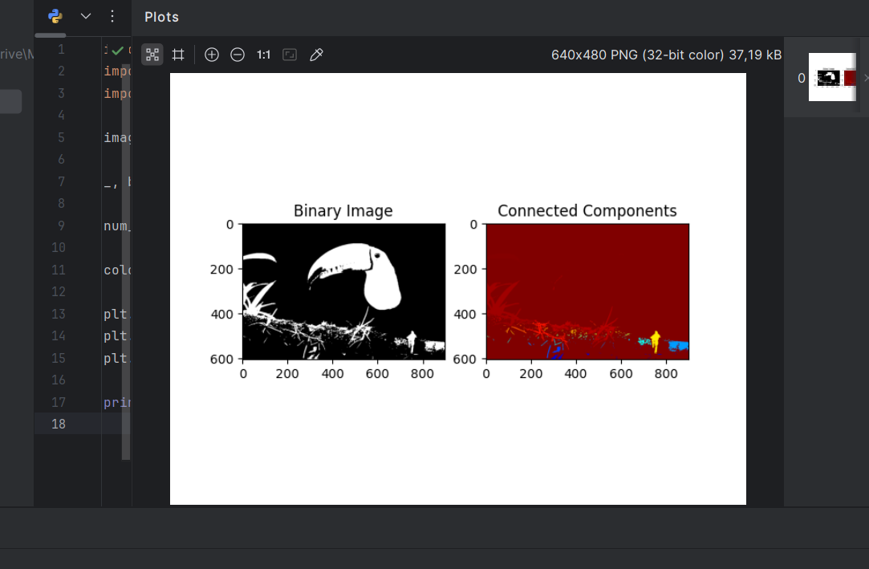
Report
Objective:
- The goal of this code is to apply Connected Component Labeling (CCL) to a binary image and visualize the different connected components found in the image.
Steps Followed:
- Input Image: The image is loaded in grayscale to facilitate the conversion to binary.
- Binary Thresholding: A threshold is applied to convert the grayscale image into a binary image.
- CCL Process: Connected components in the binary image are identified, and each component is assigned a unique label.
- Visualization: The binary image and the labeled components are visualized side by side. Each component is given a unique color to distinguish it.
- Component Count: The number of connected components is printed, excluding the background.
Output:
- The program outputs:
  - A visual representation of the binary image.
  - A color-coded labeled image where each connected component is shown in a unique color.
  - The total number of connected components detected in the image (excluding the background).
Use Cases:
- This method is useful for identifying and analyzing distinct objects in an image, such as in object recognition, segmentation, or feature extraction tasks. The connected components can represent individual objects or regions of interest in the image.

